HOMEWORK 3

Student ID: P76087099 Name: Nguyen Vu Le Minh

**Block design Screenshot:**

(Please attach a screenshot and describe the block design function.)

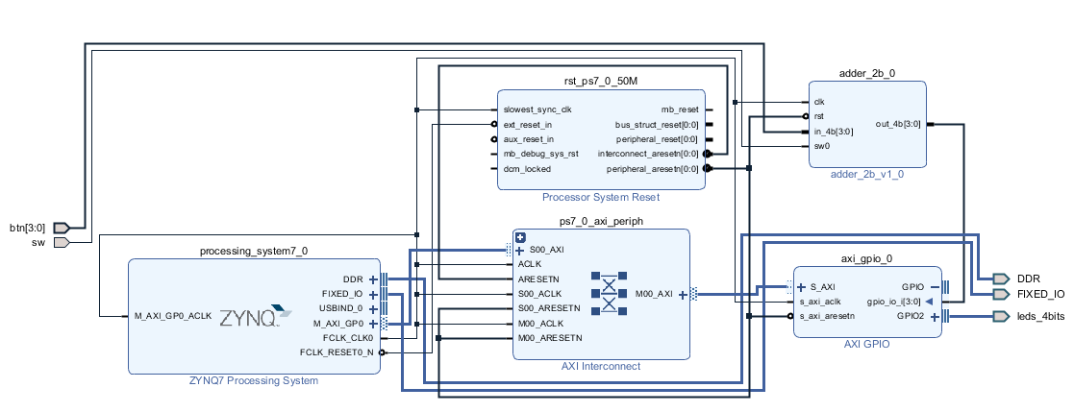

There are 4 block that is: ZYNQ7 Processing system, AXI GPIO, Adder_2b_1v_0 , Processor system reset and AXI interconnect.

* ZYNQ7 Processing system: consists of an system-on-chip (SoC) style integrated processing system (PS) and a Programmable Logic (PL) unit, providing an extensible and flexible SoC solution on a single die.
* AXI GPIO: providing a general purpose input/output interface to an AXI4-Lite interface. The AXI GPIO can be configured as either a single or a dual-channel device.
* Adder_2b_1v_0: This block can be put into hardware integrated circuit by IP, and the corresponding software design is completed to verify the functionality of the system. If the switch is equal 1, the output will equal {2’b0, in_4b[3:2]} + {2’b0, in_4b[1:0]}. On the other hand, If the switch is equal 1, the output will equal {2’b0, in_4b[3:2]} - {2’b0, in_4b[1:0]}.The leds_4bits will light through AXI_GPIO with width is 4.
* Processor system reset: allows the customer to tailor the design to suit their application by setting certain parameters to enable/disable features.
* AXI interconnect: connecting one or more AXI memory-mapped Master devices to one or more memory-mapped Slave devices.

**Jupyter python code:**

(Please describe the function and execution flow of the jupyter python code.)

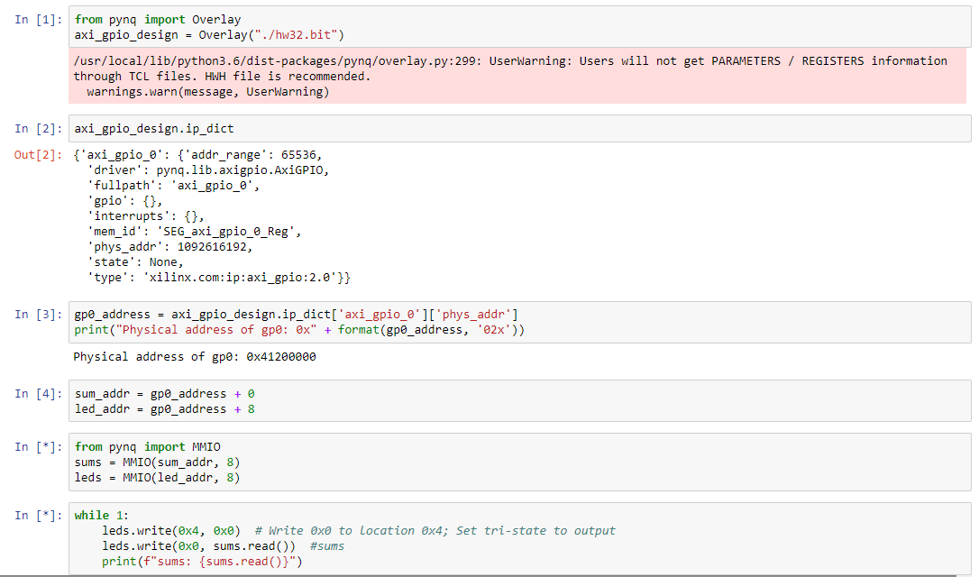

* In the input [1], we read the hw32.bit which contains all information of hardware and it is exported by Vivado.
* In the input [2], we use a command that is “axi_gpio_design.ip_dict” which is used to determine information in dictionary IPs. The important information is included that the IP driver, physical address, version.
* In the input [3], the gp0_address value is a dictionary mapping the physical address. The operation address of axi_gpio_0 is 0x41200000.
* In the input [4], the operation address of the led and sum (the sum is calculated when buttons are pressing) are determined.
* In the input [5], the library MMIO is used to map value of variables with IO address of hardware. Led is showed depend on the calculation of Adder_2b_1v_0 block when we press button in hardware.

**Lesson learn**

(Please write down the experience of completing this assignment, what you learned, and the points of difficulty.)

When I finished this homework, I learned many knowledge about design hardware by Vivado. Beside that, I can create a customer block and connect it with my project by IP.

I learned how to export file bitstream and file TCL. From that I can upload to Jupyter to operate my PYNQ-Z2.

About Jupyter, I learned how to create a url Jupyter for myself by a static IP. From that, I can know how to use it.